Backup/ Restore of LMS course

A teacher can create a backup or download an existing backup for safe keeping, or for use on another course.

How to take backup of your course:

- Open the course you want to take the backup.

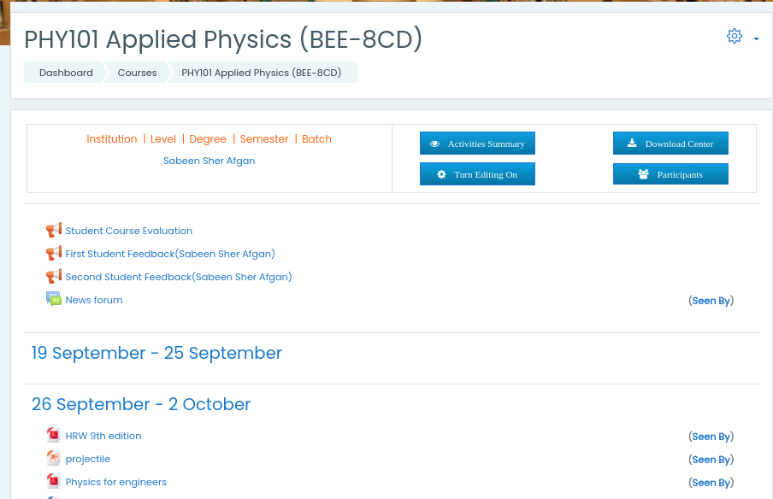

- Click on the “Action menu” (The gear icon) to expand the menu.

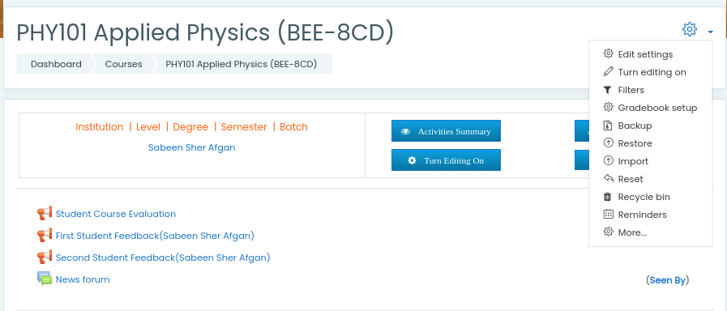

- Click on the “Backup” link and check all the checkboxes of the activities you want to include in your backup and click on the “Next” button.
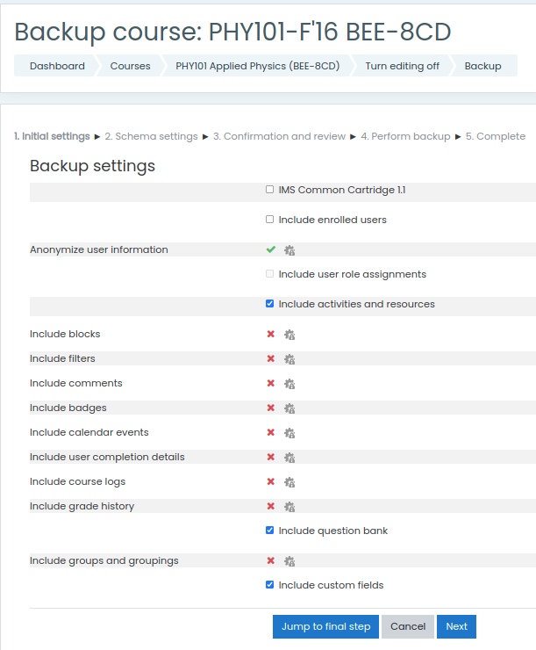

- After selection of the individual or all activities/ resources, click on the “Next” button.
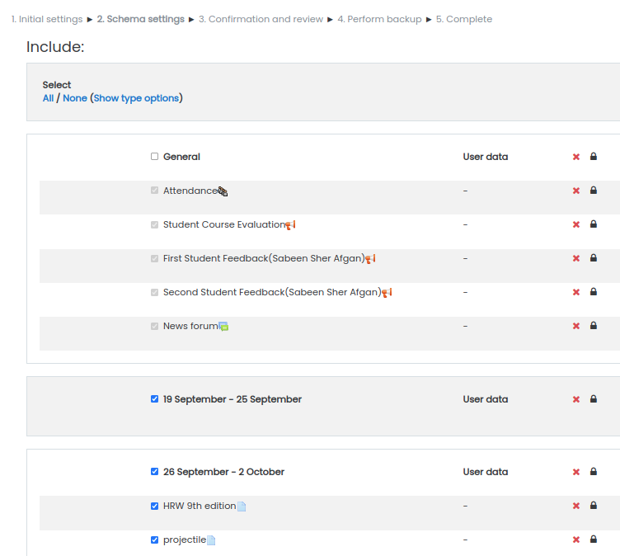

- Write the name of the backup file and click on the button “Perform Backup”.

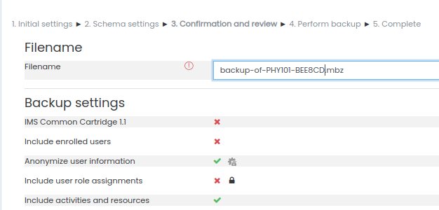


- The time for backup will depend on the size of contents included for backup.

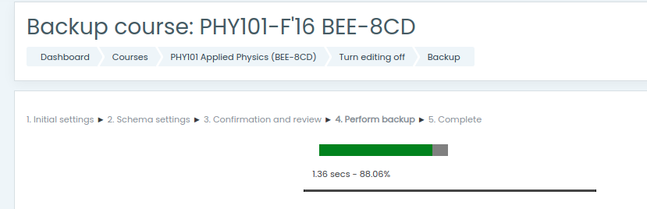

- After completion of the backup, a successful backup message will appear.

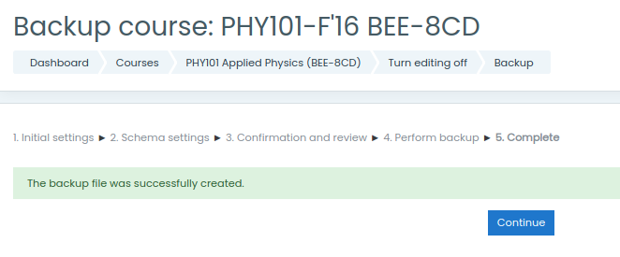

How to restore your course:

- Open the course, when you want to restore the backup and select the “Restore” option from the dropdown menu of the course “Action menu”.

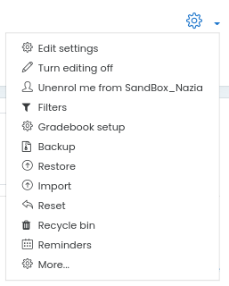

- Backup file can be selected from your computer, the course backup are or your private backup area

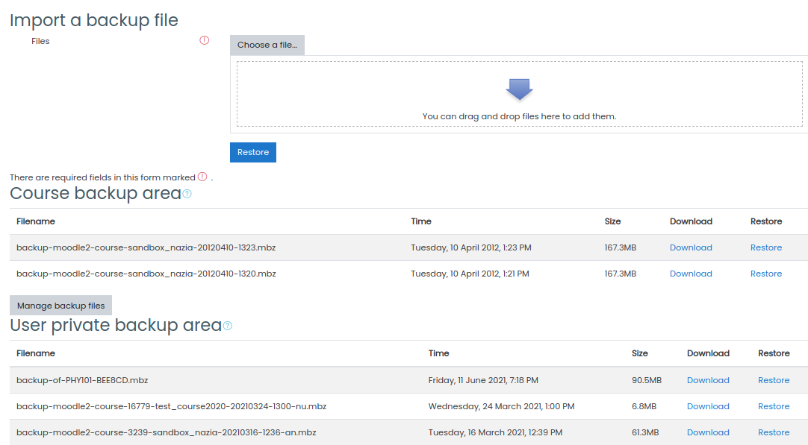

- After selecting the backup file, click on the “Restore” button (for the backup file uploading from your computer system) and the link of respective “Restore” available for the desired backup file.

- All details of the backup will be displayed before you continue.

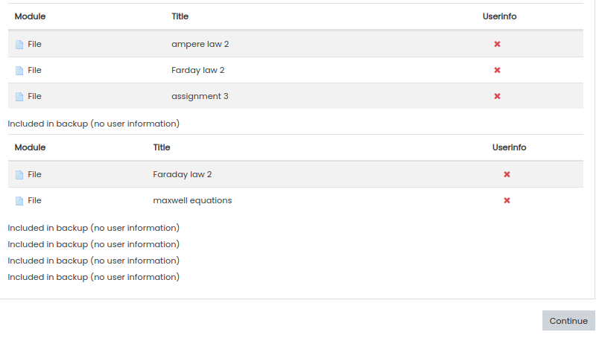
- Select the “continue” option for “Restore into this course” and proceed to “Next”.

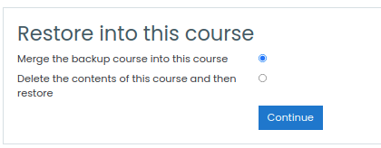

- Verify all the contents you want to restore into this course and click on the button “Perform restore”

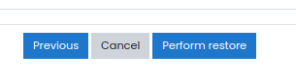
- The restore progress will be displayed.
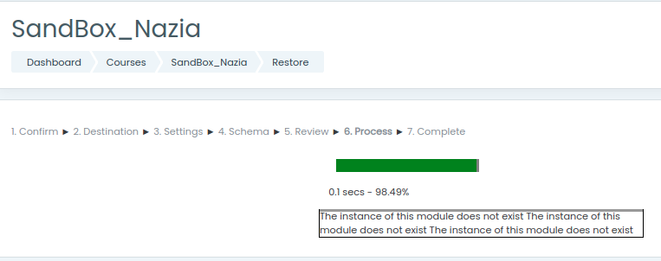

- Successful restore message will appear, click on the “Continue” button to view all the restored contents in the new course.





